Myanmar Institute of Information Technology

II Semester 2024-2025

Special Project PROJ 3001 Final-term Report
Tour Guide Assistant for Bagan Pagodas

Presented by:
Khaing Thazin Tun (2019-MIIT-CSE-014)
Kyaw Zay Ya Hein (2022-MIIT-CSE-014)
Htun Lei Lei Win (2022-MIIT-CSE-033)
Phyu Hnin Aung (2022-MIIT-CSE-040)

Instructor in charge : Dr. Myat Thuzar Tun
Project Supervisor : Daw Khin Myat Nwe Win

SEPTEMBER 20, 2025
MYANMAR INSTITUTE OF INFORMATION TECHNOLOGY

Acknowledgement
We wish to extend our profound appreciation to the Government of the Union of Myanmar and the Myanmar Institute of Information Technology (MIIT) for granting us the opportunity to carry out this project. Their continued support and encouragement have provided us with a strong foundation to successfully complete our work.
We are deeply thankful to Dr. Win Aye, Rector of MIIT, and Dr. Myat Thuzar Tun, Pro-Rector of MIIT, for permitting us to undertake this project as part of our academic program. Their guidance and vision have been a constant source of motivation throughout the course of this project.
We are especially indebted to our supervisor, Daw Khin Myat Nwe Win, whose mentorship, critical insights, and unwavering support have been invaluable. Her expertise and thoughtful direction greatly shaped the development and execution of the “Tour Guide Assistant for Bagan Pagodas” project.
We also wish to acknowledge the professors and faculty members of MIIT who offered constructive comments and helpful suggestions during our midterm presentation. Their contributions helped us refine our work and enhance the overall quality of the project.
Finally, we extend our gratitude to all members of our team for their dedication, effort, and collaborative spirit. The successful completion of this project is the result of their hard work and commitment.
Self-declaration by the students
We, the undersigned students, declare that this Final Report, submitted as part of the requirements for the Special Project in the II Semester of 2024-2025, is the result of our own efforts under the guidance of Daw Khin Myat Nwe Win at the Myanmar Institute of Information Technology.
All content within this report, including text, figures, tables, and other materials, is our original work unless otherwise acknowledged. We have provided proper citations and credit for any external sources utilized.
We also certify that this report upholds the principles of academic honesty and is entirely free from plagiarism. We take full responsibility for maintaining the ethical standards of this work and for addressing any violations, should they occur.
Date 25.9.2025 Khaing Thazin Tun
(2019- MIIT-CSE -014)
Kyaw Zay Ya Hein
(2022-MIIT-CSE-014)
Htun Lei Lei Win
(2022-MIIT-CSE-033)
Phyu Hnin Aung
(2022-MIIT-CSE-040)

Certificate
This is to certify that the report submitted Khaing Thazin Tun (2019-MIIT-CSE-014), Kyaw Zay Ya Hein (2022-MIIT-CSE-014), Htun Lei Lei Win (2022-MIIT-CSE-033) and Phyu Hnin Aung (2022-MIIT-CSE-040), under the guidance of Daw Khin Myat Nwe Win is a record of the work carried out by the students as part of their Special Project during the II Semester of the 2024-2025 academic year.
This report has been submitted in partial fulfillment of the requirements for the Bachelor of Engineering (Honors) Degree in Computer Science and Engineering.
_______________ ________________
Name: Dr. Win Aye Name: Dr. Myat Thuzar Tun
Title: Rector Title: Pro-Rector
Organization: MIIT Organization: MIIT

Abstract
Bagan, Myanmar, is renowned for its thousands of temples and pagodas spread across a large area, making navigation challenging for tourists. This project develops a web-based Tour Guide Assistant that helps users efficiently plan routes between pagodas and landmarks.
The system features an interactive frontend built with HTML, CSS, and JavaScript, providing a user-friendly interface for selecting starting points, destinations, and viewing routes. The backend, developed in Python, handles routed logic, pathfinding computations using the A* (A-Star) algorithm, and communicates with the database through a RESTful API. A MongoDB database stores information about landmarks, route connections, and path statuses, enabling scalable and flexible data management.
By combining real-time pathfinding with detailed landmark information—including Ananda Temple, Dhammayangyi Temple, Alodawpyae Pagoda, and Shwezigon Pagoda—the system helps tourists save time, avoid confusion, and enjoy a smoother travel experience. The framework is scalable and can be adapted to other tourist destinations in the future
Table of Contents
Chapter 1 1
Introduction 1
1.1 Background 1
1.2 Objectives 1
1.3 Scope 2
1.4 Project Description 2
1.5 Project Schedule 3
Chapter 2 4
Technology Used 4
2.1 Front-End 4
2.1.1 Hyper Text Markup Language (HTML) 4
2.1.2 Cascading Style Sheets (CSS) 4
2.1.3 JavaScript-Based Web 4
2.1.4 Leaflet.js (Map Library) 4
2.2 Back-End 5
2.2.1 Python 5
2.2.2 Flask (Web Framework & API) 5
2.3 Database 6
2.3.1 MongoDB 6
2.4 Algorithm 7
2.4.1 A Star Algorithm 7
2.5 Tools 7
2.5.1 Visual Studio Code 7
Chapter 3 8
System Design and Flowchart 8
3.1 System Design 8
3.2 Flowchart and picture of the system design 9
3.3 Why A* 10

3.4 Heuristic 11
3.5 Step-by-Step Algorithm 11
3.6 Finding Shortest Path from Ananda to Thambula Pagoda 12
Chapter 4 14
System Implementation 14
4.1 Requirements 14
4.1.1 Functional Requirements 14
4.1.2 Non-Functional Requirements 14
4.1.3 Implementation Steps 15
4.2 Website Implementation (User System) 15
4.2.1 Home Page 15
4.2.2 Authentication System (Login & Register) 19
4.2.3 User Profile & Personalized Pagoda Tracker 20
4.2.4 AI Chatbot Assistant 22
4.2.5 Interactive Map & Pathfinding Page 23
4.2.6 Comprehensive Pagodas Listing Page 25
4.2.7 Pagoda Details Page (Gateway Page) 26
4.2.8 Pagoda Information Page (Full Details Page) 28
4.2.9 Responsive Design (For Whole Website) 30
4.3 Website Implementation (Admin System) 31
4.3.1 Admin Login & Authentication 31
4.3.2 Admin Dashboard 31
4.3.3 Pagoda Management 32
4.3.4 User Management 33
4.3.5 System Health Monitoring 34
4.3.6 Admin Activity Logs 35
Chapter 5 36
Conclusion 36
5.1 Summary 36
5.2 Future Enhancements 36
References 37

List of Figures
Figure 3.1 Flowchart of User System 9
Figure 3.2 Flowchart of Admin System 10
Figure 3.3 Heuristic 11
Figure 3.4 Dataset of Heuristic Distance to Thambula 12
Figure 3.5 Stages (a) and (b) in an A∗ search for Thambula 12
Figure 3.6 Stages (c) and (d) in an A∗ search for Thambula 13
Figure 3.7 Stage (e) in an A∗ search for Thambula 13
Figure 4.1 Home Page (English) 16
Figure 4.2 Home Page (Myanmar) 17
Figure 4.3 Home Page (About Us) 17
Figure 4.4 Home Page (How It Works) 18
Figure 4.5 Home Page (Famous Pagodas) 18
Figure 4.6 User Registration Popup 19
Figure 4.7 User Login Popup 20
Figure 4.8 User Profile Page 21
Figure 4.9 Personalized Pagoda Tracker Page (My Favorites) 21
Figure 4.10 Personalized Pagoda Tracker Page (Visited Pagodas) 22
Figure 4.11 AI Chatbot Interface 22
Figure 4.12 Interactive Map Page 23
Figure 4.13 Reminder To Log In 24
Figure 4.14 Pathfinding Page 24
Figure 4.15 Interactive Map with Routed Path 25
Figure 4.16 Pagoda Listing Page with Search 26
Figure 4.17 Pagoda Details Page (Information & Map) 27
Figure 4.18 Pagoda Details Page (Nearest Pagodas) 27

Figure 4.19 Pagoda Information Page 28
Figure 4.20 Pagoda Information Page (Some Sections) 28
Figure 4.21 Pagoda Information Page (Some Sections) 29
Figure 4.22 Pagoda Information Page (Some Sections) 29
Figure 4.23 Home Page (Responsive Design) 30
Figure 4.24 Hamburger Nav-Drawer (Responsive Design) 30
Figure 4.25 Admin Login Page 31
Figure 4.26 Admin Dashboard 32
Figure 4.27 Pagoda Management Page 33
Figure 4.28 User Management Interface 34
Figure 4.29 System Health Dashboard 34
Figure 4.30 Admin Activity Logs 35

List of Tables

Table 1.1 Project Schedule 3

Chapter 1
Introduction
1.1 Background
Bagan, Myanmar, is an ancient city with thousands of pagodas spread across a vast area, making it challenging for tourists to navigate efficiently. Traditional guides and printed maps often fail to offer real-time, optimized navigation. With advancements in web-based technologies and AI algorithms, a smart route-planning system can significantly improve tourist experiences in such heritage zones.
1.2 Objectives
- To design and implement a smart algorithm for shortest pathfinding on a grid-based map.

- To help tourists easily navigate between landmarks in Bagan.

- To build a user-friendly web interface with real-time routing.

- To store and manage location and path data effectively using a database.

- To allow future scalability for other regions beyond Bagan.

- To help reduce tourist confusion, improve route efficiency, and enhance user travel experience in cultural heritage zones.

1.3 Scope
The system will be accessible through any modern web browser and optimized for both desktop and mobile devices. It is designed for tourists, tour guides, and cultural heritage enthusiasts visiting Bagan. Users will be able to view an interactive map, select pagodas to visit, and get the shortest route calculated using the A* algorithm. The platform will also provide historical and cultural information for each pagoda, enhancing both navigation and learning experience.
1.4 Project Description
The Tour Guide Assistant for Bagan Pagodas is a web-based application designed to help users navigate Bagan's historical landmarks. It provides an interactive platform where users can select starting and destination points to find the shortest route between pagodas.
The application uses the A* (A-Star) algorithm to calculate the most efficient path, accounting for real-world distances and travel restrictions. The shortest route, along with details about each pagoda's history and visiting tips, is displayed on a dynamic map. Users can also customize tours based on time or walking distance, making the app a flexible guide for exploring the region.
The frontend is built with HTML, CSS, and JavaScript, while the backend, developed in Python, handles API requests and executes path-finding calculations. The system stores data on landmarks, paths, and blocked routes in a MongoDB database, with a RESTful API connecting the components.
Ultimately, the Tour Guide Assistant for Bagan Pagodas enhances the tourist experience by automating route planning, reducing travel time, and providing an intuitive interface for simple navigation.

1.5 Project Schedule
Table 1.1 Project Schedule

Tasks | July | August | September
Research and Software Requirements
Project Outline
Developing
Midterm Report
Midterm Presentation
Adding Features
Final Report and Presentation

Chapter 2

Technology Used
2.1 Front-End
2.1.1 Hyper Text Markup Language (HTML)
HTML is the standard markup language used to structure content on the web. It defines the layout and elements of a web page such as headings, paragraphs, forms, buttons, and links. In this project, HTML provides the basic structure of the user interface, including the homepage, map page, login and registration forms, and pagoda information pages.
2.1.2 Cascading Style Sheets (CSS)
CSS is a stylesheet language used to design and style HTML pages. It controls the presentation of elements such as colors, fonts, spacing, and layout. In this project, CSS ensures the application is user-friendly and visually appealing, with responsive layouts that adapt to both desktop and mobile screens.
2.1.3 JavaScript-Based Web
JavaScript is a client-side scripting language that makes web applications interactive and dynamic. It enables functions such as form validation, real-time updates, and handling user interactions on the map. In this project, JavaScript works with Leaflet.js to:
- Render the interactive map of Bagan.
- Display pagoda markers and popups.
- Trigger route calculations by calling the backend API.
- Dynamically show the shortest path returned by the A* algorithm.
2.1.4 Leaflet.js (Map Library)
Leaflet.js is an open-source JavaScript library widely used for building interactive maps. It is lightweight, mobile-friendly, and easy to integrate with modern web applications. Leaflet provides essential mapping features such as panning, zooming, markers, and popups, which make it suitable for developing web-based GIS (Geographic Information Systems).
In this project, Leaflet.js is used to render the interactive map of Bagan. It allows users to:
- View the geographical layout of pagodas.
- Select one or more pagodas directly on the map.
- Display the shortest path generated by the A* algorithm.
- Access cultural and historical information through map markers and popups.
By combining Leaflet with other web technologies, the system ensures a user-friendly interface where tourists can easily navigate Bagan’s heritage sites both on desktop and mobile devices.
2.2 Back-End
2.2.1 Python
Python is a high-level, versatile programming language widely used in web development, AI, and data science. Its simplicity and large ecosystem of libraries make it suitable for building efficient backends. In this project, Python powers the backend server (using Flask) and implements the A* pathfinding algorithm. Python handles requests from the frontend, processes user inputs, retrieves pagoda data from MongoDB, and returns the shortest path results.
2.2.2 Flask (Web Framework & API)
Flask is a lightweight, open-source web framework for Python. It is designed to be simple, flexible, and easy to extend, making it ideal for projects that require custom backends without unnecessary complexity. Flask follows the microframework approach, meaning it provides only the core features and allows developers to add extensions as needed.
In this project, Flask is used to build the backend API that connects the frontend with the database and the A* algorithm. Its role includes:
- Handling user authentication (sign up, login).
- Providing RESTful APIs for fetching pagoda details and cultural information from MongoDB.
- Exposing an API endpoint to run the A* path-finding algorithm and return the shortest route between selected pagodas.
- Managing communication between the front end (HTML, CSS, JS, Leaflet.js) and the database (MongoDB).
2.3 Database
2.3.1 MongoDB
MongoDB is a NoSQL, document-oriented database designed for scalability, flexibility, and high performance. Instead of storing data in tables and rows like relational databases, MongoDB stores information in JSON-like documents, making it easier to represent complex and hierarchical data.
In this project, MongoDB is used to store and manage:
- Pagoda information (name, history, cultural details, GPS coordinates).
- Route data represented as graphs (nodes for pagodas, edges for distances/paths).
- User information such as login credentials and preferences.
MongoDB works seamlessly with the Flask backend, providing efficient data retrieval for user requests. For example, when a user selects a pagoda, MongoDB returns its details and coordinates, which are then used in the A* path-finding algorithm to generate the shortest route.
By using MongoDB, the system ensures that data is easily extendable (new pagodas, routes, or cultural tags can be added without modifying the schema) and supports fast queries, which are essential for real-time navigation.

2.4 Algorithm
2.4.1 A* Search Algorithm
The A* (A-star) algorithm is a pathfinding and graph traversal algorithm widely used in navigation systems, GPS, and games. It finds the shortest path between two points by combining the advantages of Dijkstra’s Algorithm and Greedy Best-First Search.
- g(n): The actual cost of the path from the start node to the current node.
- h(n): The estimated cost (heuristic) from the current node to the goal.
- f(n): The total estimated cost of the path through node n, given by:
f(n)=g(n)+h(n)f(n) = g(n) + h(n)f(n)=g(n)+h(n)
In this project, A* is used to calculate the shortest route between pagodas in Bagan, taking into account geographical distance and travel restrictions.
2.5 Tools
2.5.1 Visual Studio Code
Visual Studio Code is a free, open-source code editor developed by Microsoft. It is lightweight, fast, and supports many programming languages and platforms. VS Code offers features like syntax highlighting, code completion, debugging, Git integration, and a wide range of extensions. Its user-friendly interface, strong performance, and active community make it suitable for web, mobile, cloud development, and programming in languages like Python and Java.

Chapter 3

System Design and Flowchart
3.1 System Design
The Tour Guide Assistant for Bagan Pagodas employs modular architecture, allowing each component to be developed, maintained, and updated independently. The design includes:
components to be developed, maintained, and updated independently. The design includes:
- User Interface Module: Provides an intuitive, responsive web interface for users to view the interactive map, select pagodas, and customize their tours.
- Route Calculation Module: Implements the A* algorithm to determine the most efficient travel route based on user-selected destinations and travel constraints.
- Database Layer: Uses MongoDB to store and retrieve landmark details, route data, and user preferences, ensuring data integrity and fast queries.

3.2 Flowchart and picture of the system design
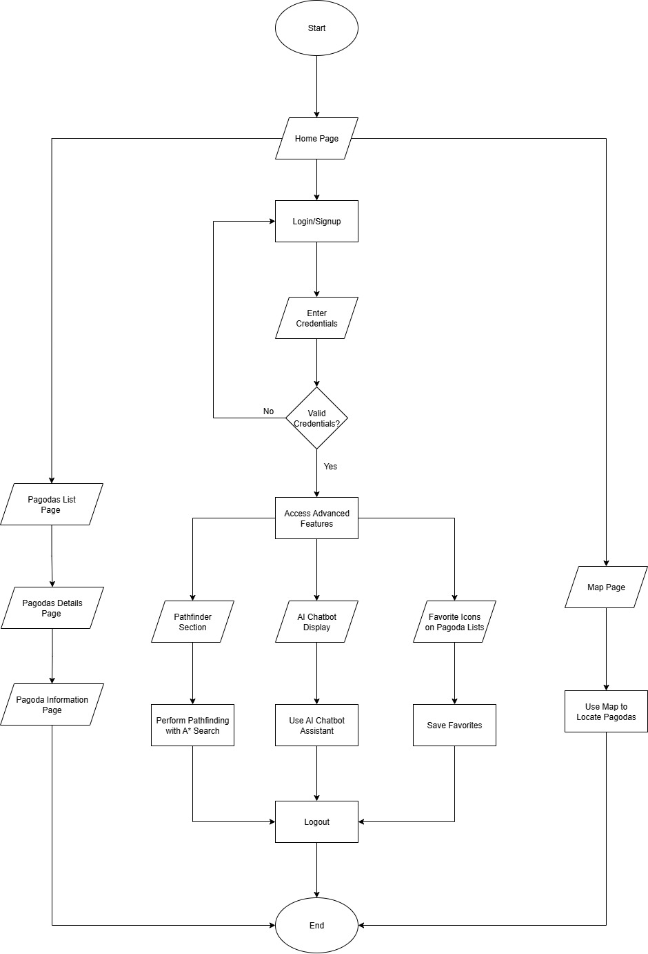
Figure 3.1. Flowchart of User System

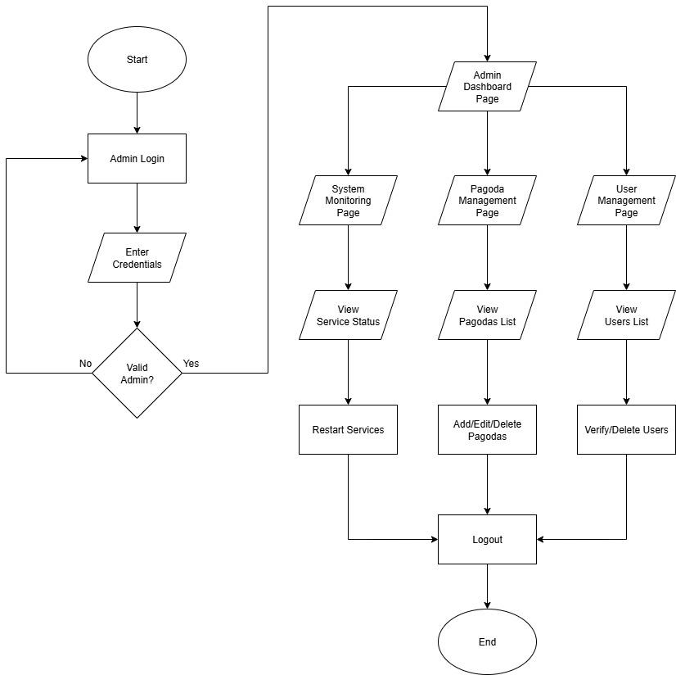
Figure 3.2. Flowchart of Admin System

3.3 Why A* Search Algorithm
- Compared to Dijkstra’s Algorithm:
  - Dijkstra explores all possible nodes equally, which can be slow.
  - A* uses heuristics to move more directly toward the goal.
- Compared to Greedy Best-First Search:
  - Greedy only considers h(n), which may lead to a suboptimal path.
  - A* balances g(n) and h(n), ensuring both efficiency and accuracy.
Thus, A* guarantees the optimal shortest path while being more efficient than Dijkstra alone.

3.4 Heuristic
To estimate h(n), we use the Haversine formula, which calculates the straight-line distance between two GPS coordinates (latitude and longitude).
Straight red line = heuristic (h)
Blue curved line = real road (g)
Heuristic guides us in the right direction faster
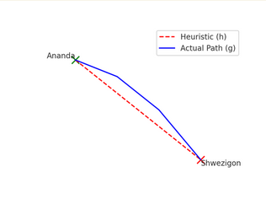
Figure 3.3. Heuristic

3.5 Step-by-Step Algorithm
- Start from the initial pagoda (node).
- Place it in the open list (nodes to be evaluated).
- Move the node with the lowest f(n) = g(n) + h(n) from the open list to the closed list.
- For each neighbor of the current node:
  - Calculate g(n), h(n), and f(n).
  - If it is not in the open list, add it.
  - If it is already there with a higher cost, update it with the lower cost.
- Repeat until the goal node (destination pagoda) is reached or the open list is empty.
- Return the reconstructed shortest path.
3.6 Finding Shortest path from Ananda Pagoda to Thambula Pagoda:

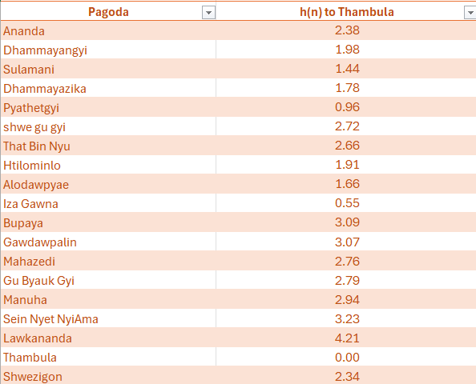
Figure 3.4 Dataset of Heuristic Distance to Thambula

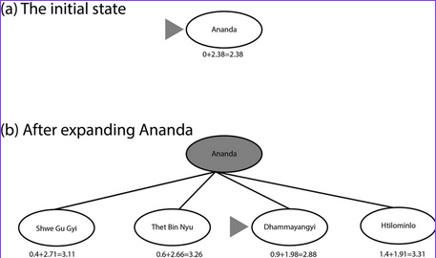
Figure 3.5 Stages (a) and (b) in an A∗ search for Thambula

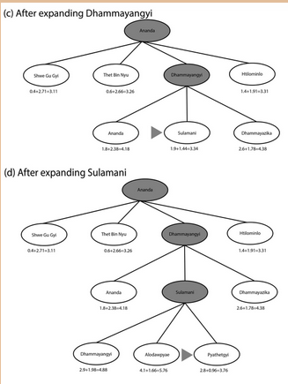
Figure 3.6 Stages (c) and (d) in an A∗ search for Thambula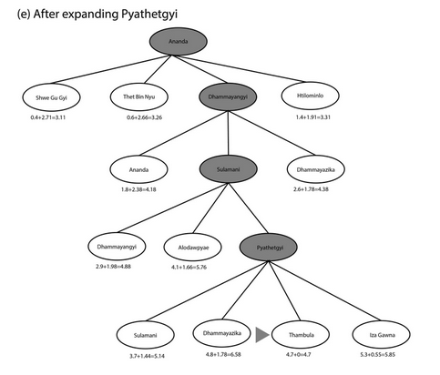
Figure 3.7 Stage (e) in an A∗ search for Thambula

Chapter 4

System Implementation
4.1 Requirements
4.1.1 Functional Requirements
The Tour Guide Assistant for Bagan Pagodas must allow users to register, log in, and manage their preferences. The system should provide an interactive map where tourists can select starting and destination points among the pagodas. Once the locations are chosen, the system must calculate the shortest route using the A* algorithm and display it clearly on the map. Along with navigation, the system should present historical and cultural details about each pagoda so that users not only find their way but also gain knowledge during their journey. Tour customization is also essential, enabling users to adjust their itineraries based on available time or walking distance. To support these functions, the backend developed in Python must process route calculations and API requests, while the MongoDB database should store and retrieve information about landmarks and route networks. Finally, the web interface must be responsive, built with HTML, CSS, and JavaScript, and testing should ensure that both unit and integration aspects of the system perform correctly and reliably.
4.1.2 Non-Functional Requirements
The system must provide fast performance, ensuring that route calculations and map displays are completed quickly without frustrating delays. It should be scalable so that future expansions can include additional pagodas, more users, or even other tourist regions. Reliability is essential, as tourists must trust that the routes provided are accurate and consistent. Usability plays a key role in this project, meaning the interface must remain simple and intuitive so that tourists of any age or background can use it with ease. Compatibility is also required, with the system accessible on both desktop and mobile devices. Security measures should be in place to protect user accounts and prevent unauthorized data access. The architecture must support easy maintenance, allowing developers to debug, fix, and update modules efficiently. Furthermore, the project must be extensible, so that additional features like AI-based recommendations, multilingual support, or mobile app integration can be implemented in the future without major redesigns.

4.1.3 Implementation Steps:
- Setup – Install Python, MongoDB and required libraries.
- Data Prep – Collect pagoda and road network data, clean, and store as nodes and edges in MongoDB with distance weights.
- Backend – Build APIs to fetch pagoda data, run shortest-path A* algorithm, and return route details.
- Frontend – Create a responsive web UI with Leaflet.js to select pagodas, display routes, and show distance.
- Database – Define collections (pagodas, nodes, edges) with 2dsphere index for geospatial queries.
- Testing – Perform unit, integration, and performance tests; fix bugs and optimize queries.

4.2 Website Implementation (User System)
4.2.1 Home Page
The Home Page of Baganetic serves as the main gateway, offering users an immersive introduction to the ancient city of Bagan. It is designed to be visually striking and informative, allowing visitors to immediately understand the platform's core purpose: intelligent, optimized exploration of Bagan's vast temple complex.
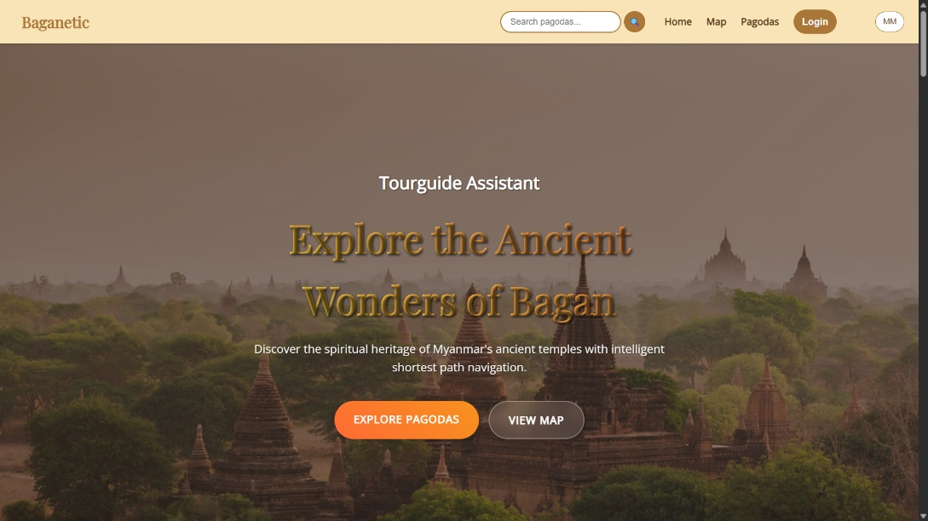
Figure 4.1 Home Page (English)
The homepage features a prominent hero section with a captivating background image of Bagan's landscape, inviting users to begin their journey. Two clear call-to-action buttons, "Explore Pagodas" and "View Map," guide users to the platform's key functionalities.
A prominent language change setting allows users to seamlessly switch between English and Myanmar, ensuring the content is accessible to a wide local and international audience. This multilingual support is a cornerstone of the user experience.
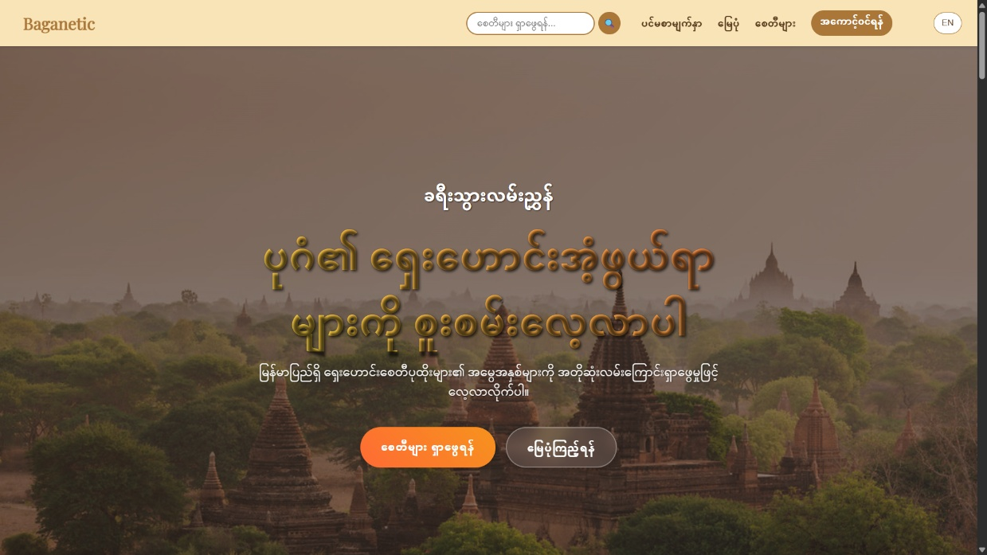Figure 4.2 Home Page (Myanmar)

The homepage also highlights key functionalities and dynamically showcases a featured selection of “Famous Pagodas”, enticing users to explore the vast cultural database the application offers.
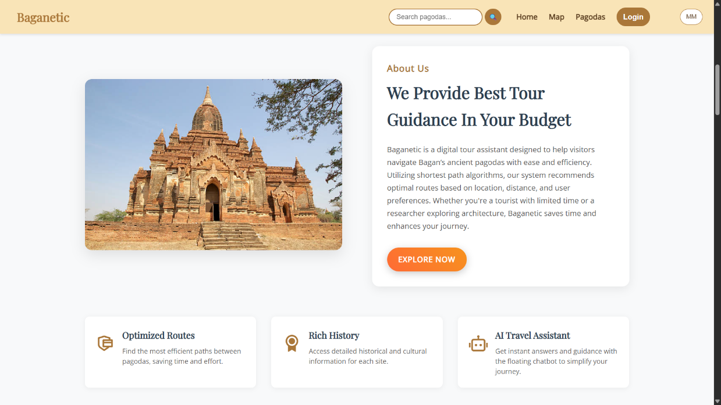
Figure 4.3 Home Page (About Us)
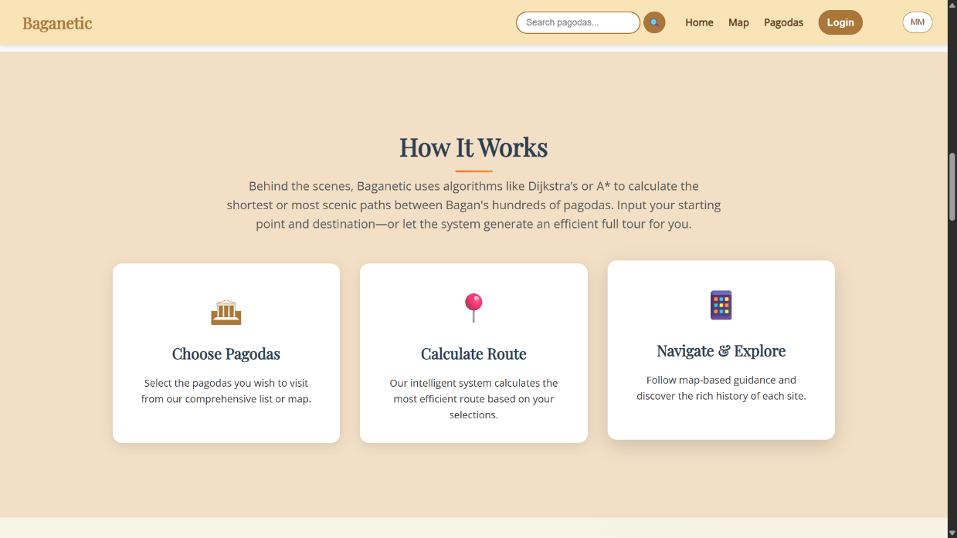
Figure 4.4 Home Page (How It Works)

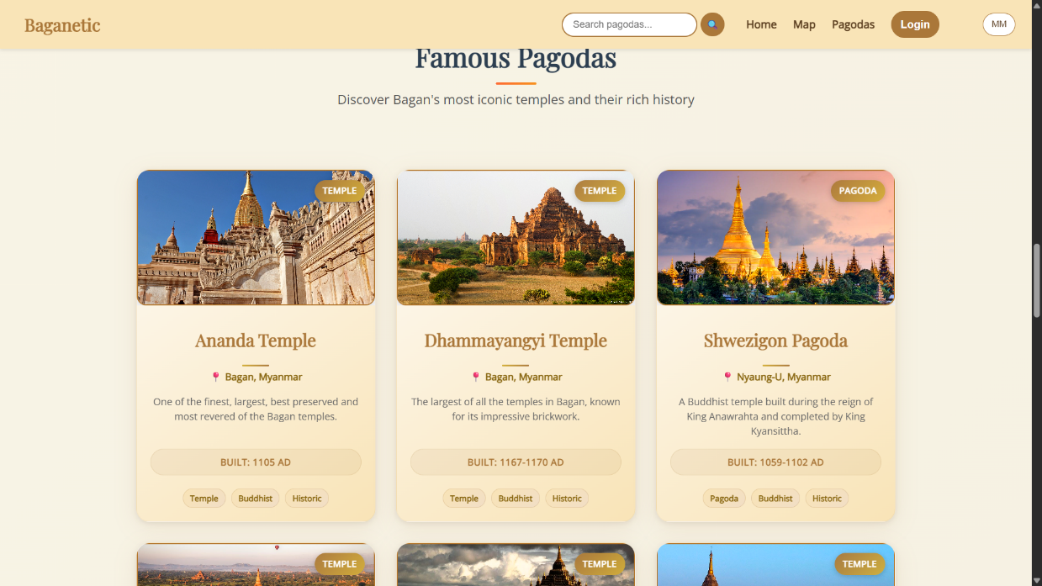
Figure 4.5 Home Page (Famous Pagodas)

4.2.2 Authentication System (Login & Register)
To access personalized features, users can securely create an account or log in to an existing one. The authentication system is seamlessly integrated into the homepage (arrived page) via a modal popup, ensuring a smooth user experience without navigating away.
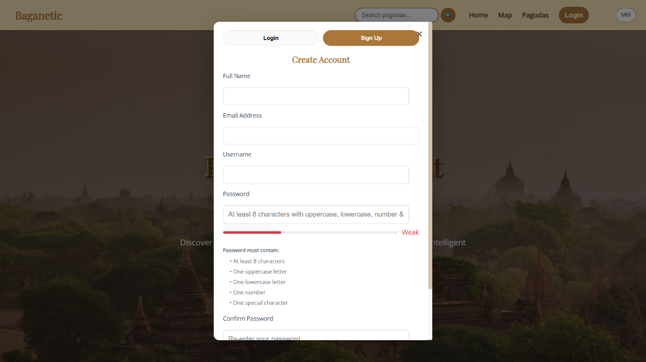Figure 4.6 User Registration Popup
The registration process includes robust form validation to ensure data integrity, enforcing strong password policies and checking for unique usernames. All user credentials are securely hashed using bcrypt before storage.

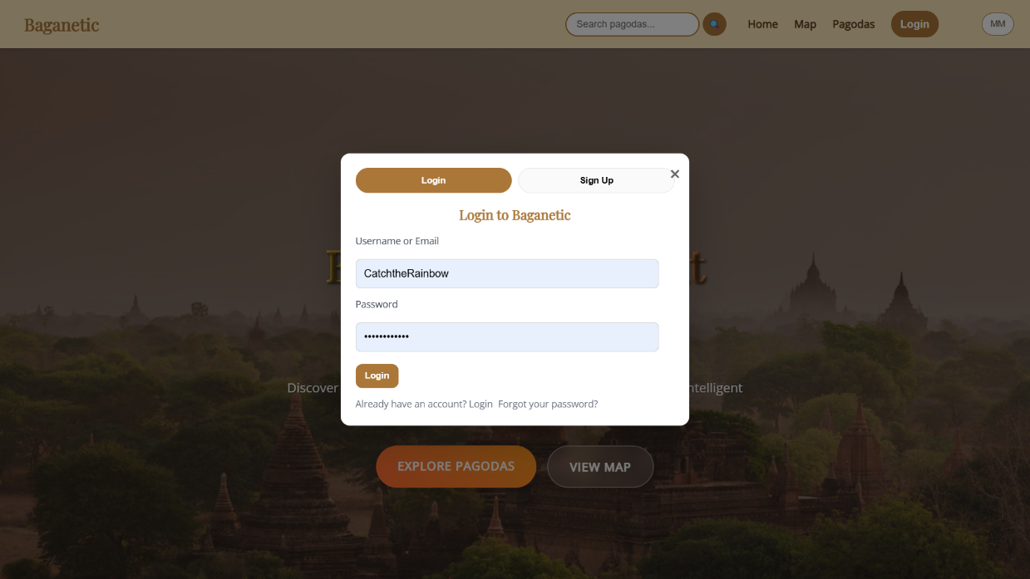
Figure 4.7 User Login Popup
Once logged in, users benefit from persistent sessions and can access a personal profile where they can save their favorite pagodas, view their search history, and manage their preferences for a tailored experience across devices. Moreover, they will be able to use AI chatbot and the core feature of route finding.

4.2.3 User Profile & Personalized Pagoda Tracker
Users can manage their account settings, review their exploration history, and update their personal information through a dedicated profile section, giving them full control over their data and experience on the platform.
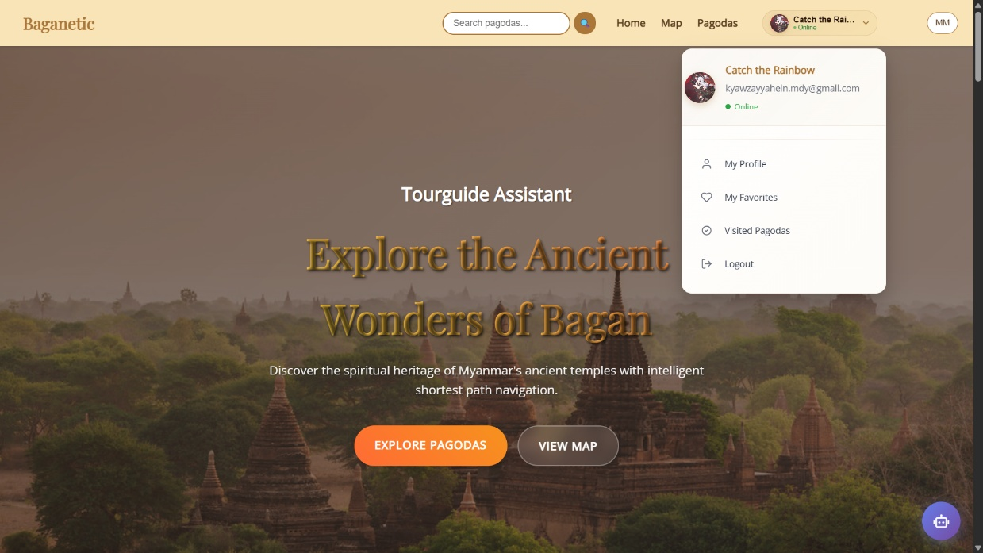
Figure 4.8 User Profile Page

A feature for logged-in users is the ability to track their exploration progress. Users can mark pagodas as "Visited," or add them to a "Favorites" list, creating a custom-tailored itinerary and personal log of their journey through Bagan.
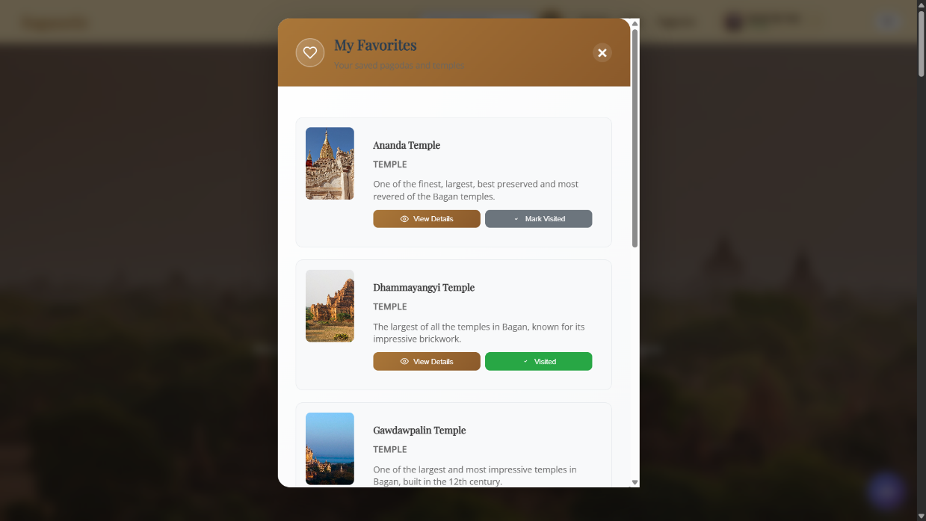
Figure 4.9 Personalized Pagoda Tracker Page (My Favorites)
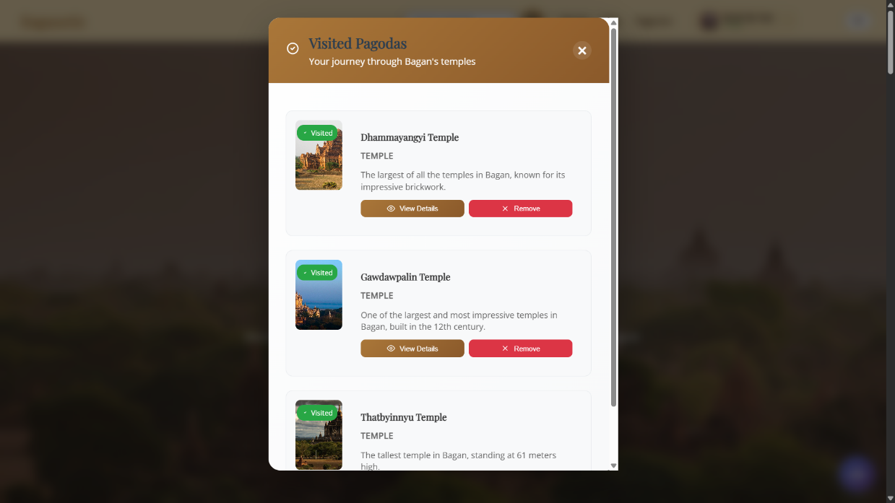
Figure 4.10 Personalized Pagoda Tracker Page (Visited Pagodas)
4.2.4 AI Chatbot Assistant
An intelligent AI-powered chatbot is accessible from the bottom-right corner of every page. This virtual assistant provides users with instant, contextual information and interactive guidance.
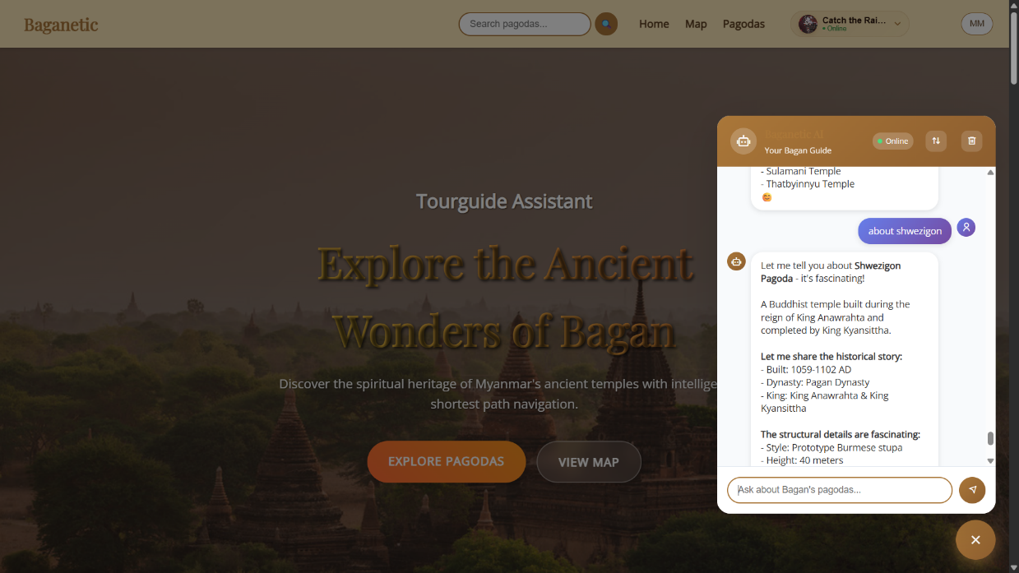Figure 4.11 AI Chatbot Interface
Users can interact with this chatbot to get instant answers to their questions about specific pagodas, historical facts, travel tips, and other system-related queries, enhancing engagement and providing immediate support. It provides a conversational and intuitive way to interact with the entire platform.

4.2.5 Interactive Map & Pathfinding Page
The Interactive Map page is the core of Baganetic's navigation system. It provides a geographical overview of all pagodas, empowering users to plan their exploration visually and efficiently using advanced algorithms.

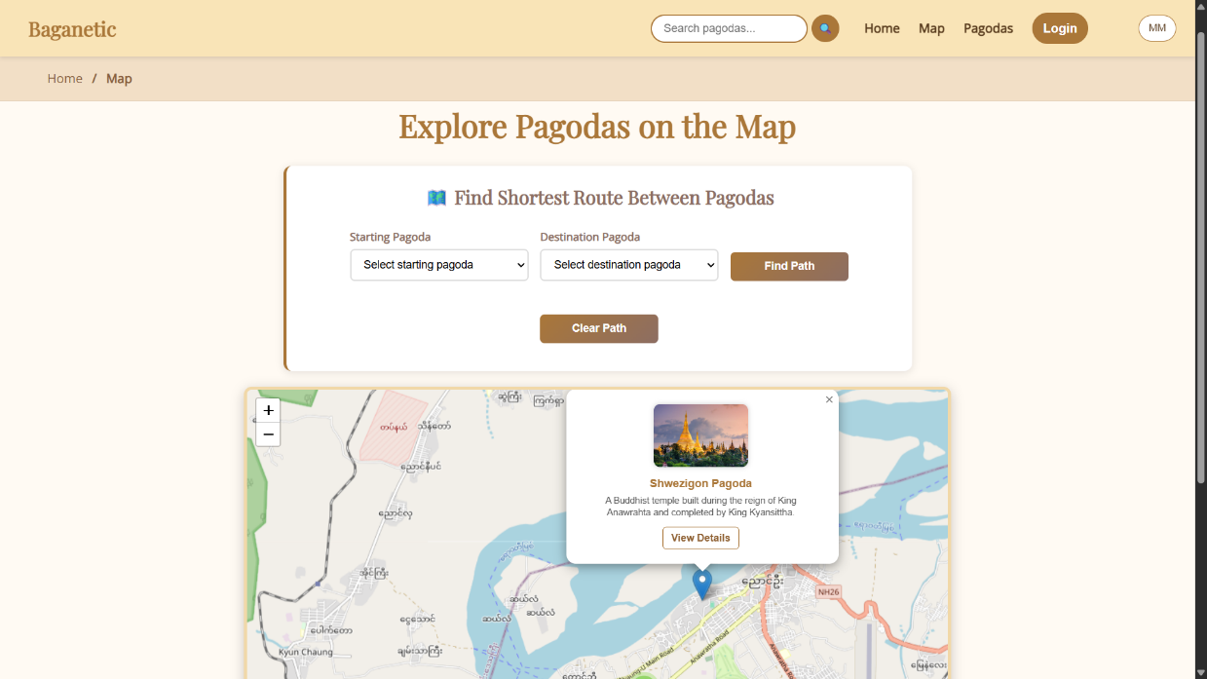
Figure 4.12 Interactive Map Page

If a user hasn’t logged-in, the alert box will appear to remind this feature is only for registered users.
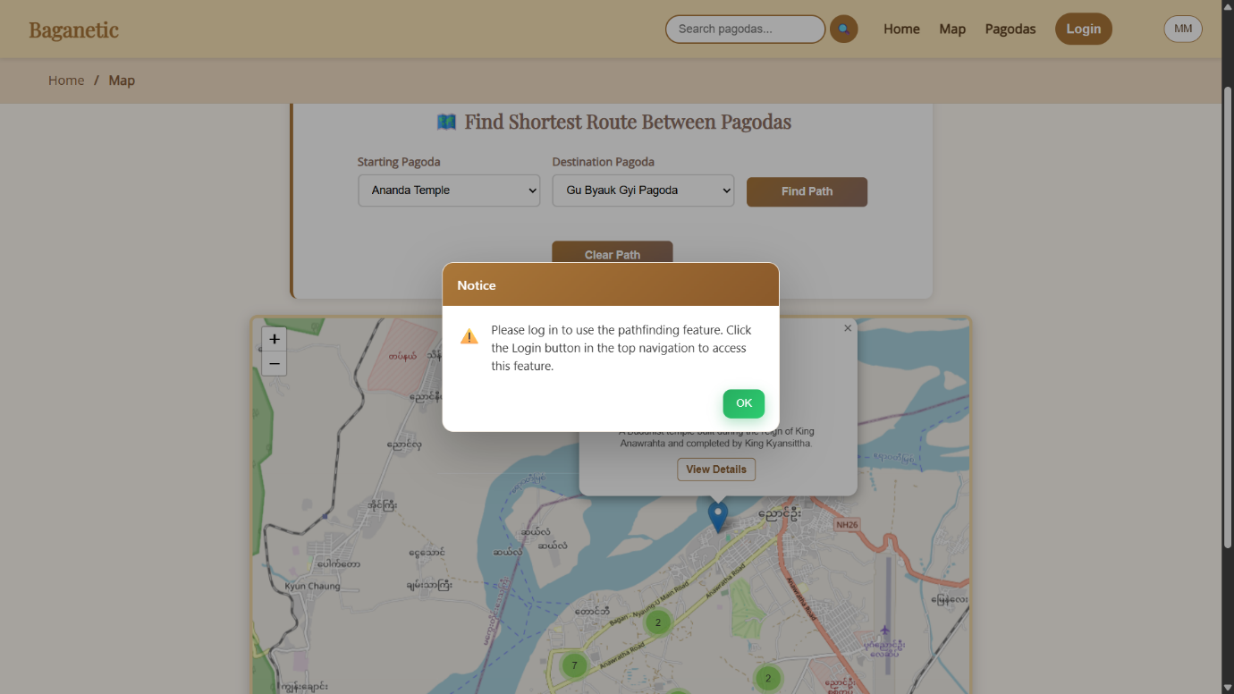
Figure 4.13 Reminder To Log In

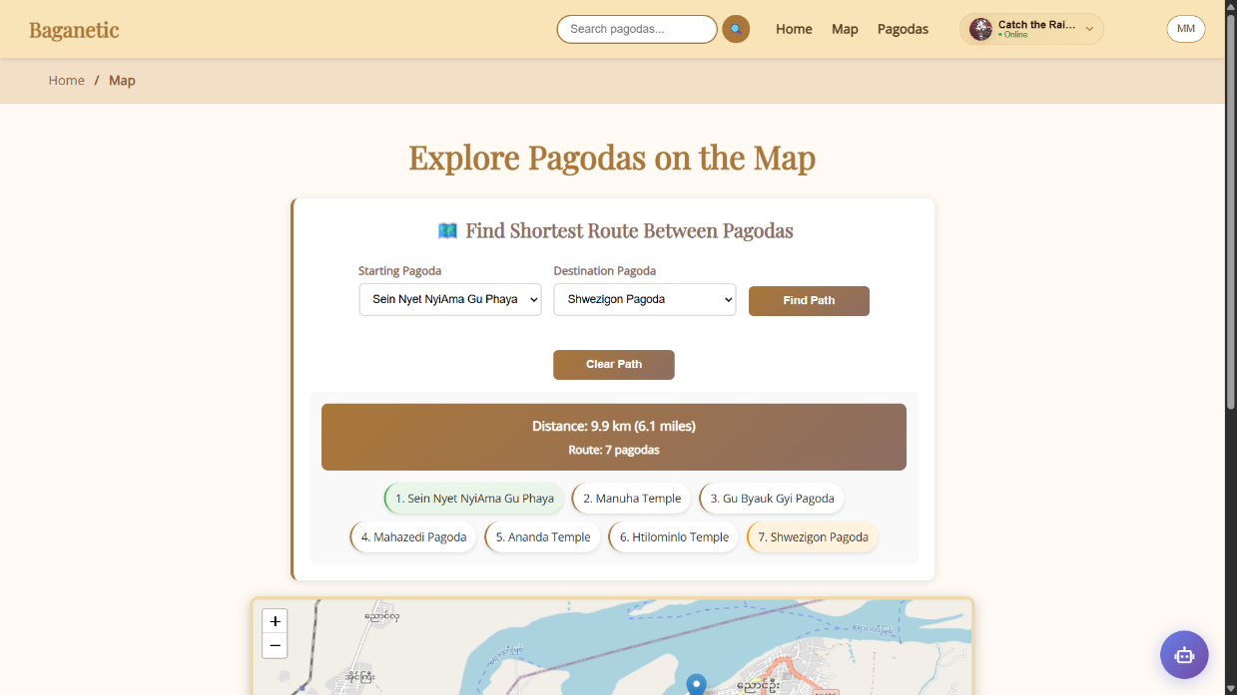Figure 4.14 Pathfinding Page
Users can select a starting point and a destination pagoda from dropdown menus. The system then utilizes the powerful A* pathfinding algorithm to calculate and display the shortest possible route between them. The optimal path is drawn directly on the map with a colored polyline, and key information such as total distance and estimated travel time is presented clearly.

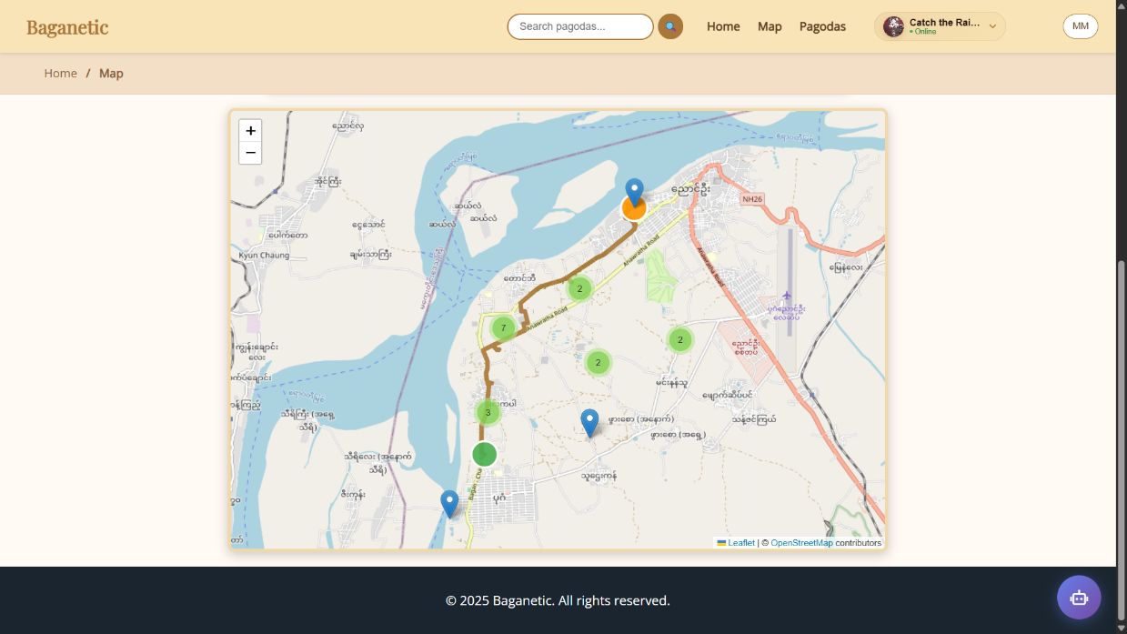Figure 4.15 Interactive Map with Routed Path

Each pagoda is represented by a clustered marker on the map. Clicking on a marker reveals a popup with the pagoda's name, a brief description, and a link to its full details page, allowing for quick discovery and deep dives into history.
4.2.6 Comprehensive Pagodas Listing Page
All users, without any registration, can freely explore this page which acts as a comprehensive digital encyclopedia for all of Bagan's pagodas. It provides a searchable and filterable database, making it easy for users to find specific temples or browse based on their interests.
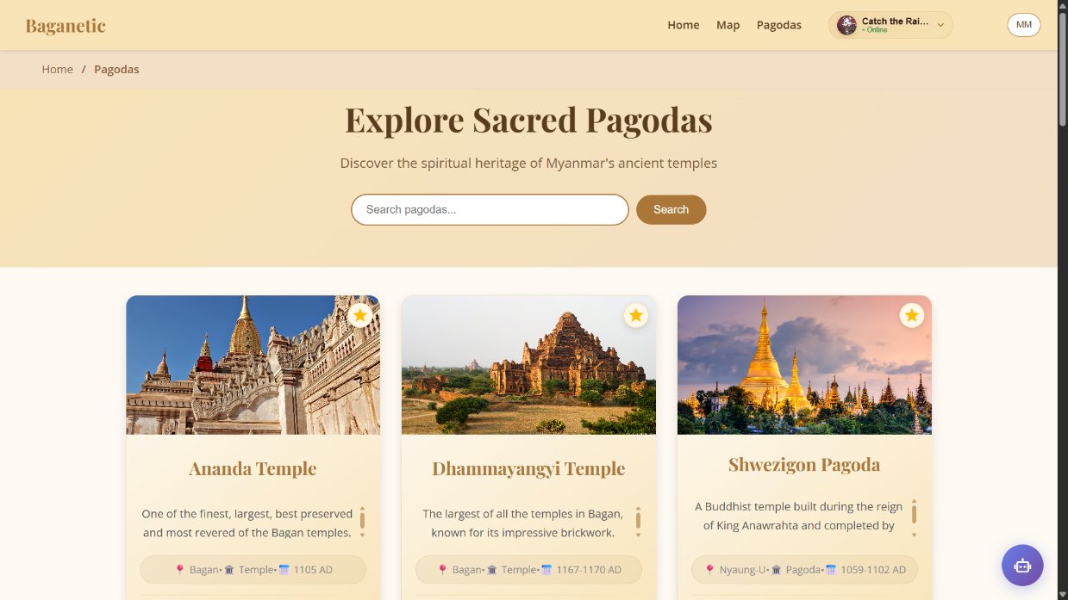Figure 4.16 Pagodas Listing Page with Search
A prominent search bar at the top allows for real-time filtering. As users type, the grid of pagoda cards updates instantly to show matches by name, historical period, or keywords. Each card displays an image of the pagoda, its name, a short description, and its general location, providing a snapshot of information to help users decide where to explore next. Logged-in users can bookmark pagodas directly from these cards to be in “Favorites” list.

4.2.7 Pagoda Details Page (Gateway Page)
Without any registration or with being logged-in, clicking on a pagoda from the listing or map leads to its dedicated details page. This page serves as the gateway for a specific pagoda, providing a general overview before allowing users to dive deeper.
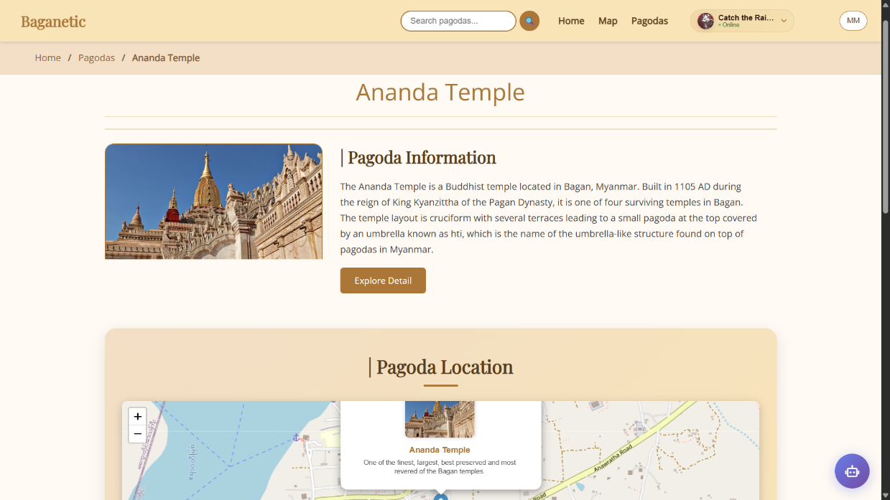Figure 4.17 Pagoda Details Page (Information & Map)
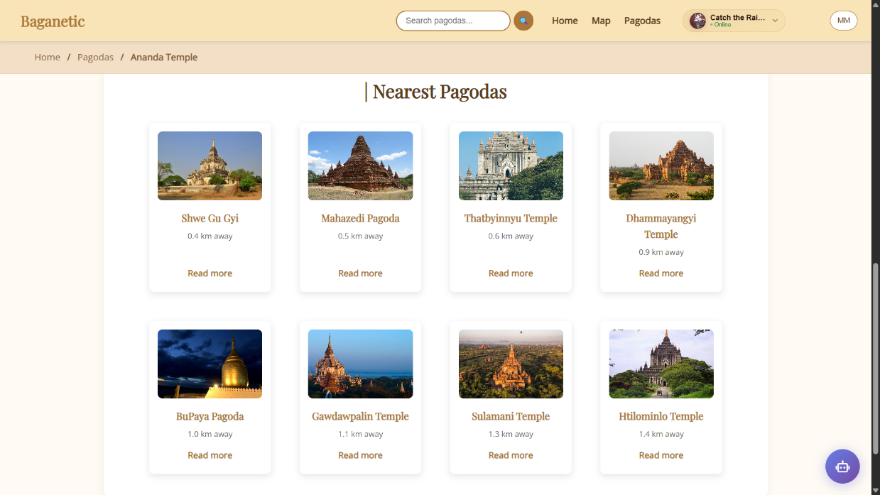Figure 4.18 Pagoda Details Page (Nearest Pagodas)
The page displays the pagoda's primary image, name, type, and a brief introduction. It includes an embedded map showing its exact location and a list of the closest pagodas to the current one, helping users plan their route. A "View Full Details" button leads to the comprehensive Pagoda Information Page for in-depth exploration.

4.2.8 Pagoda Information Page (Full Details Page)
This page offers a deep dive into all available information about a single pagoda, serving as a rich cultural and historical resource. This also can be used with both registration and no registration.
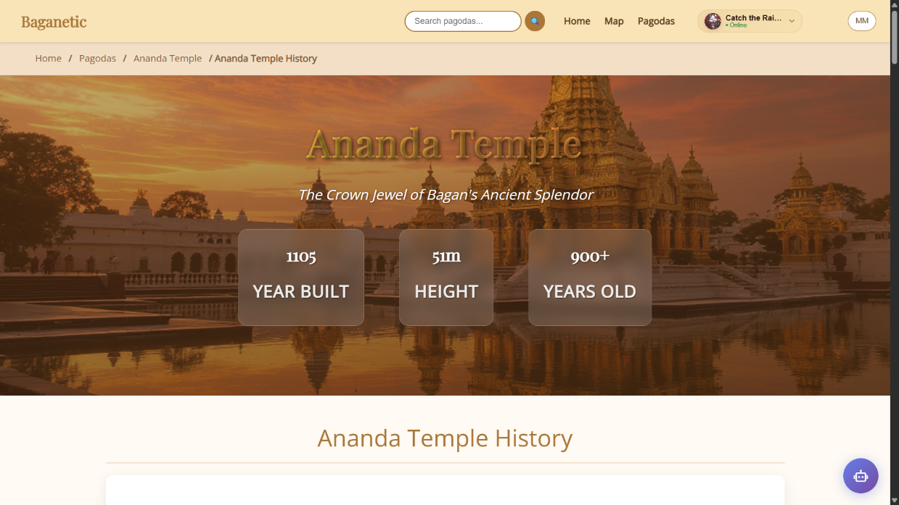Figure 4.19 Pagoda Information Page
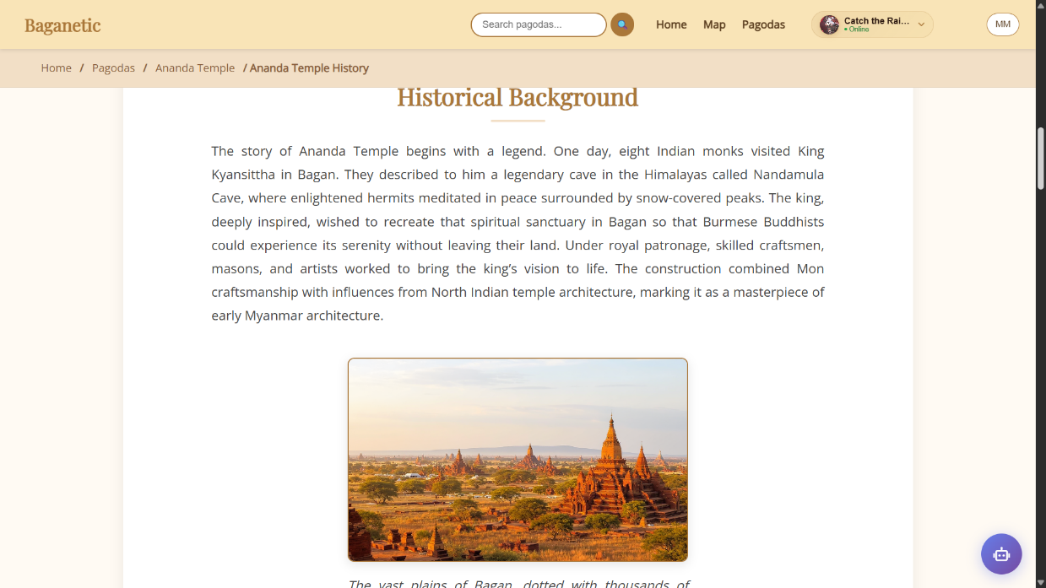
Figure 4.20 Pagoda Information Page (Some Sections)
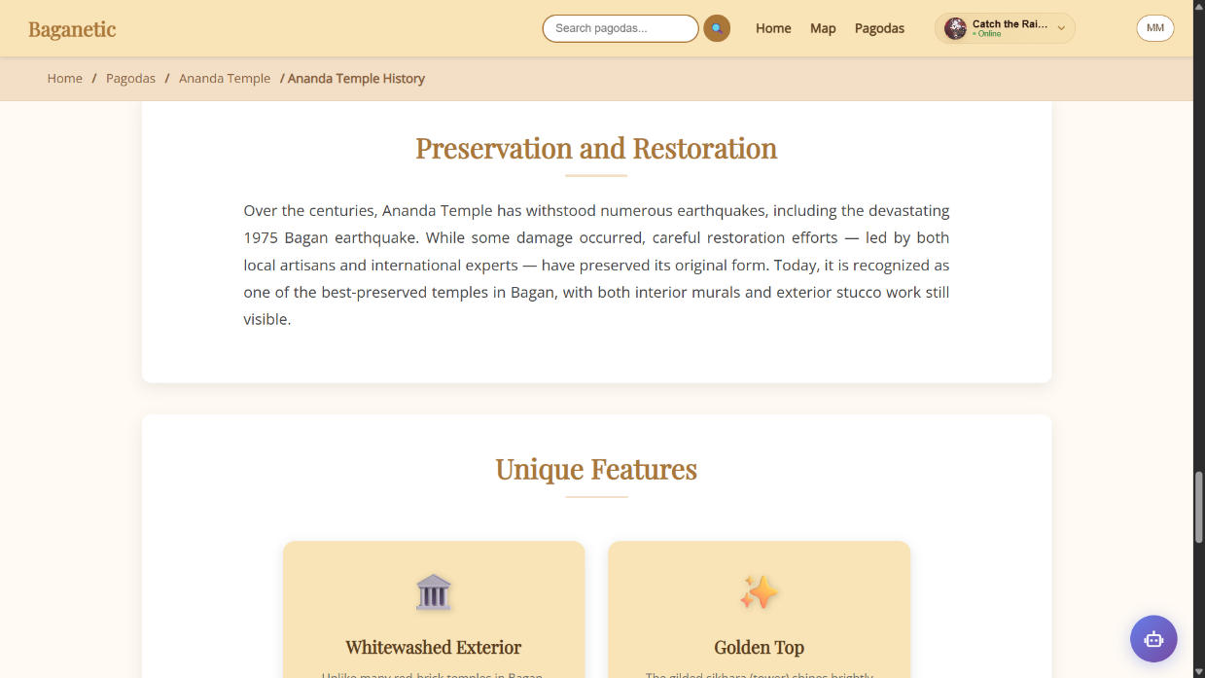
Figure 4.21 Pagoda Information Page (Some Sections)
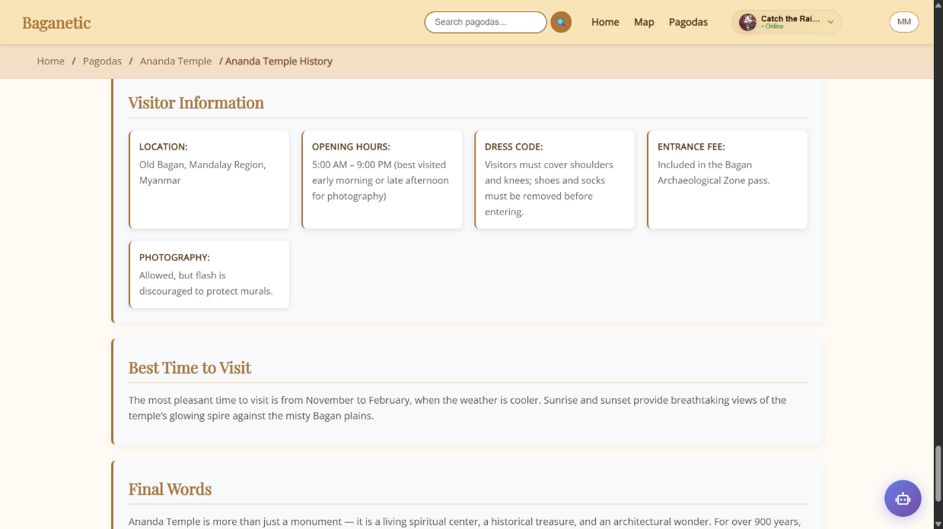
Figure 4.22 Pagoda Information Page (Some Sections)
The page is structured into clear sections detailing the pagoda's history, architectural style, cultural significance, and construction period. It also features an image gallery which allows users to visually explore the temple.

4.2.9 Responsive Design (For Whole Website)
The responsive design strategy for Baganetic follows a mobile-first approach, ensuring optimal performance and user experience on mobile devices while progressively enhancing the interface for larger screens. The design system utilizes three primary breakpoints: 768px for tablets and 1024px for desktop devices.
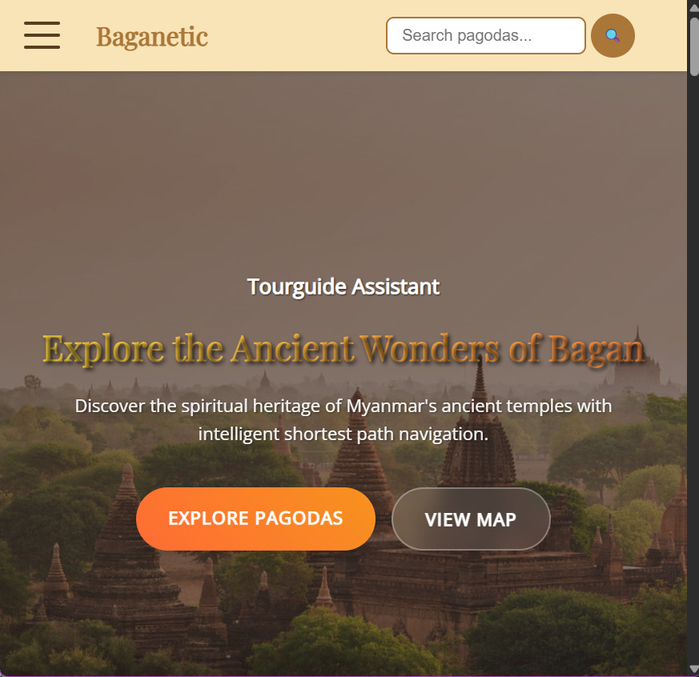
Figure 4.23 Home Page (Responsive Design)
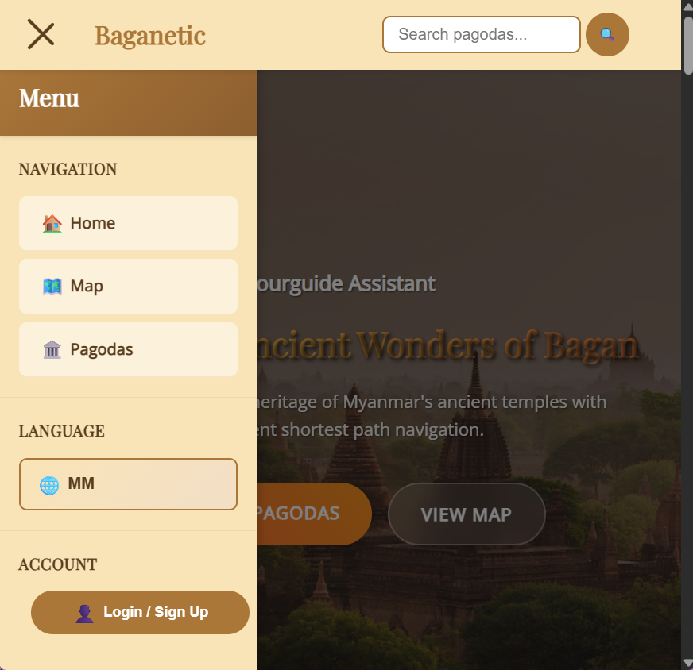
Figure 4.24 Hamburger Nav-Drawer (Responsive Design)

4.3 Website Implementation (Admin System)
4.3.1 Admin Login & Authentication
The Admin System is a secure, separate module that provides authorized personnel with complete control over the Baganetic application. Access is strictly controlled through a robust authentication gateway.
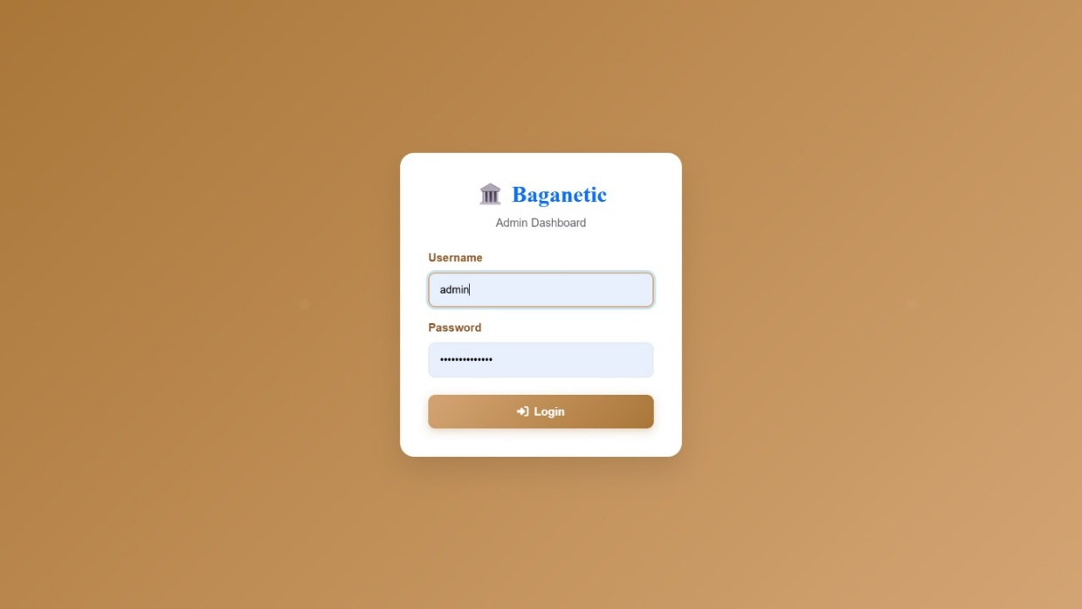
Figure 4.25 Admin Login Page
Administrators must provide valid credentials (Username and Password) to gain entry. The system incorporates advanced security measures including brute force protection—which automatically locks the account after 5 failed attempts—and enforcing a secure 30 minutes session timeout protect against unauthorized access. All admin actions require authentication, and sensitive operations are validated and logged to ensure system integrity and compliance.
4.3.2 Admin Dashboard
The Admin Dashboard serves as the central control hub for the Baganetic platform, providing administrators with a comprehensive and intuitive interface to manage all aspects of the system, upon successful login. It offers real-time insights, system health monitoring, and quick access to key management functions.
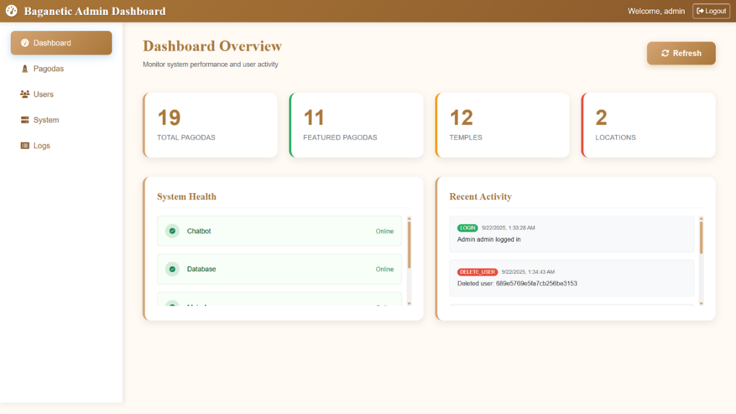
Figure 4.26 Admin Dashboard Overview
Administrators can monitor system performance, track user activity, and manage content seamlessly through a clean and responsive interface designed for efficiency and ease of use.
4.3.3 Pagoda Management
This section is the core of the content management system, allowing administrators to perform full CRUD (Create, Read, Update, Delete) operations on pagoda and temple entries. This includes adding new pagodas, editing existing ones, and removing outdated or incorrect entries.
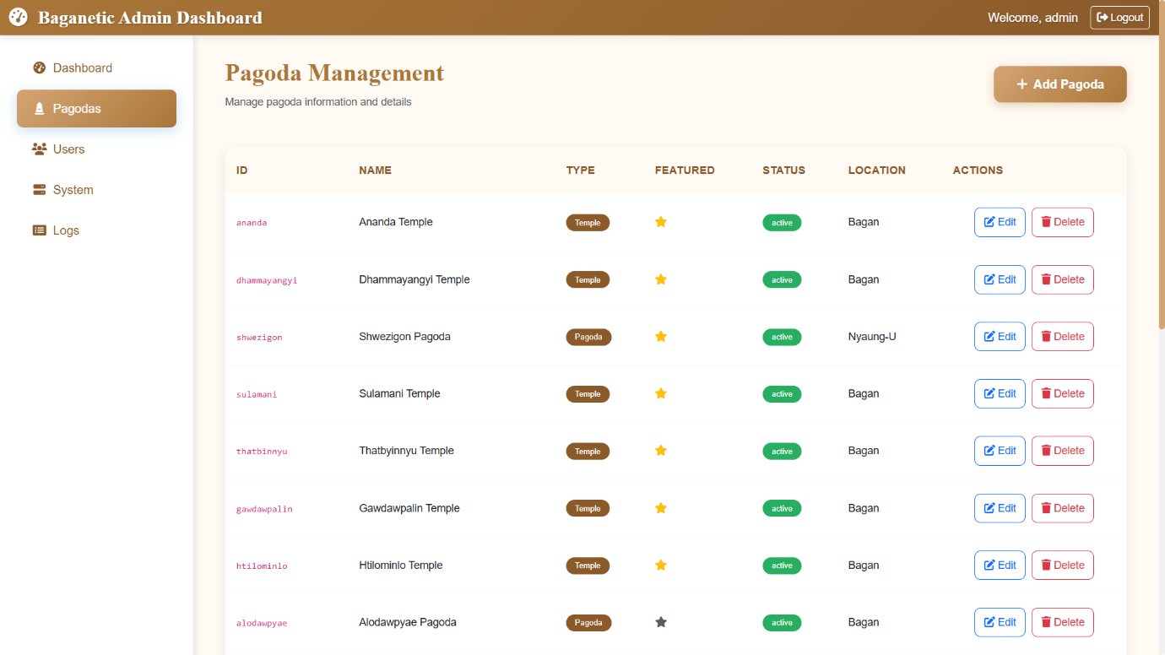
Figure 4.27 Pagoda Management Page

All changes are synchronized in real-time with both the MongoDB database and the frontend data files, ensuring consistency across the application. Administrators can also mark pagodas as “featured” or “active” to control their visibility on the main site.
4.3.4 User Management
The User Management page provides a detailed overview of all registered users. Administrators can view user statistics, monitor verification statuses, and manage user accounts effectively.
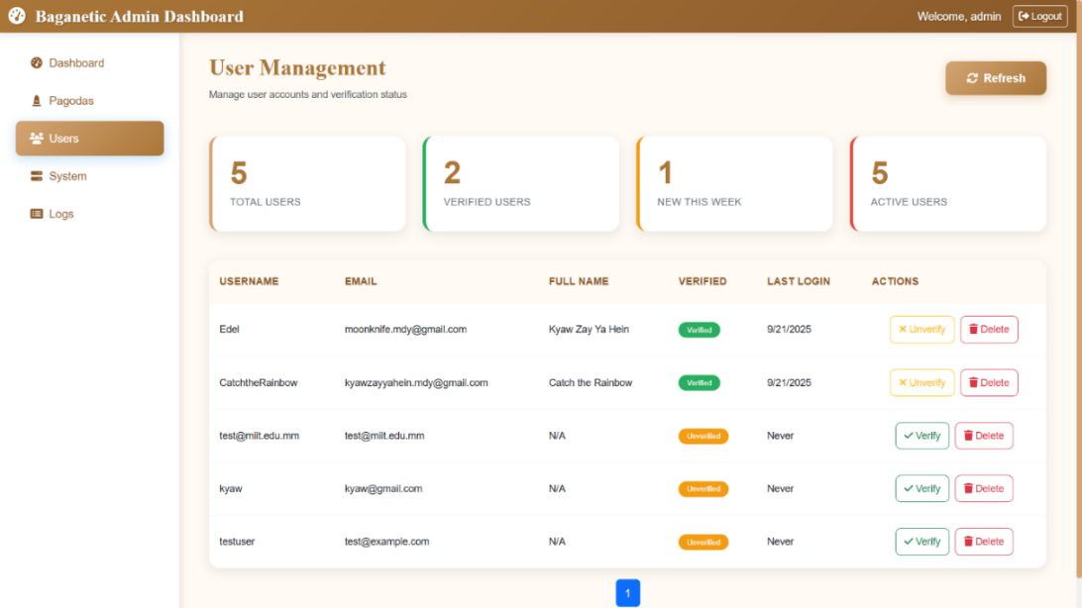
Figure 4.28 User Management Interface

Key features include the ability to delete users, update roles, and track recent user activity. The interface supports pagination to handle large datasets and includes search and filter options for efficient user management.
4.3.5 System Health Monitoring
The System Management page offers real-time monitoring of all backend services, including the main Flask app, chatbot service, Node.js server, and MongoDB database.
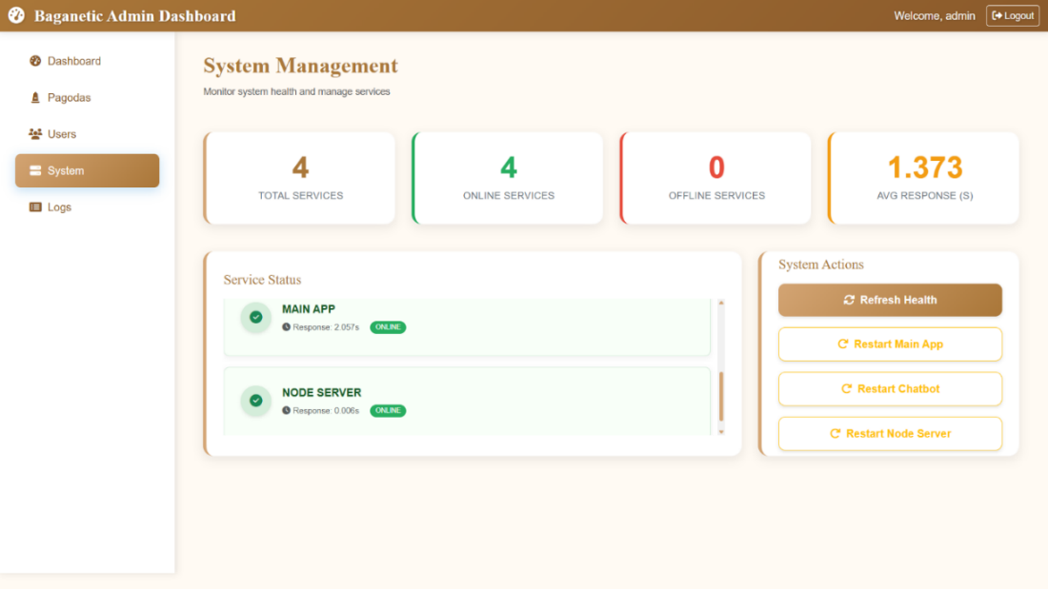
Figure 4.29 System Health Dashboard

Administrators can view service statuses, response times, and error logs. The system also allows for manual service restarts and provides detailed error messages to facilitate quick troubleshooting.

4.3.6 Admin Activity Logs
The Admin Logs page maintains a complete audit trail of all administrative actions, including logins, content updates, and system changes.
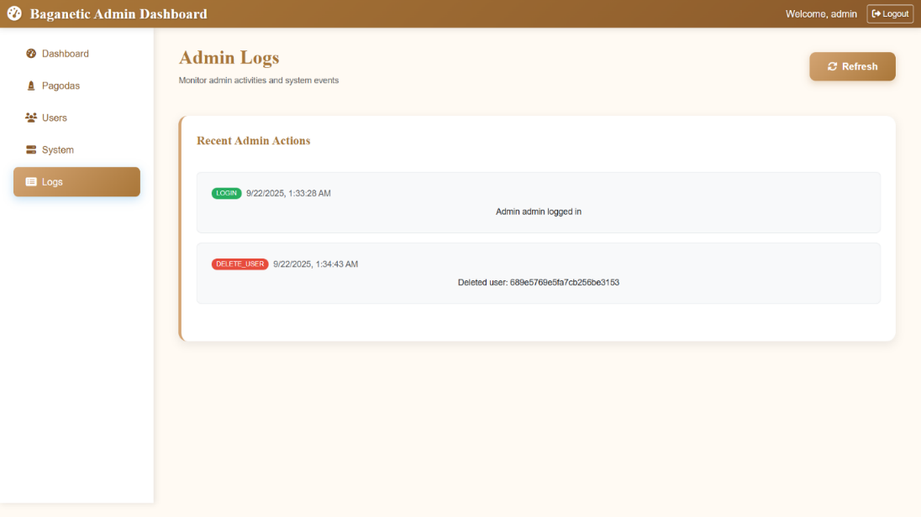
Figure 4.30 Admin Activity Logs
Logs are displayed in a readable format with timestamps, action descriptions, and user session details. The log view is searchable and limited to the most recent entries for clarity and performance.

Chapter 5

Conclusion
5.1 Summary
The Tour Guide Assistant for Bagan Pagodas addresses key challenges faced by tourists and tour guides in navigating the Bagan Archaeological Zone. By providing an interactive map, real-time pathfinding using the A* algorithm, and detailed information about pagodas, the system simplifies route planning and enhances the overall tourism experience. The use of a web-based platform with a Python backend and MongoDB database ensures flexibility, scalability, and reliability. Users can efficiently plan multi-stop itineraries, avoid blocked or restricted paths, and explore Bagan’s historic landmarks with confidence and ease.

5.2 Future Enhancements
- Mobile App Development: Create native Android and iOS applications to allow offline navigation and greater accessibility.
- AI-Powered Recommendations: Implement algorithms to suggest optimal pagoda tours based on user preferences, time, and distance.
- Multi-Language Support: Include support for multiple languages to cater to international tourists.
- Integration with External Services: Connect with APIs for real-time updates on weather, road conditions, or tourism events.
- User Feedback & Analytics: Collect user feedback and analyze usage patterns to improve route suggestions and enhance the user experience.

References

- Artificial Intelligence, A Modern Approach, Third Edition, Stuart J. Russell and Peter Norvig
- Leaflet JS : https://leafletjs.com/reference.html
- MongoDB : https://www.mongodb.com/docs/manual/

